# **Urteko edo hilabeteko fakturazioa**

Bi txostenetan sailkatuta egongo da enpresaren fakturazioa.

· Urtero

| 2020 | 124.547€ |
| --- | --- |
| 2021 | 86.032€ |
| 2022 | 102.321€ |

· Hilabetez

| 2021 | Billing |
| --- | --- |
| January | 12.534€ |
| February | 8.321€ |
| March | 10.942€ |
| April | 14.876€ |

· Grafiko Bitartez:

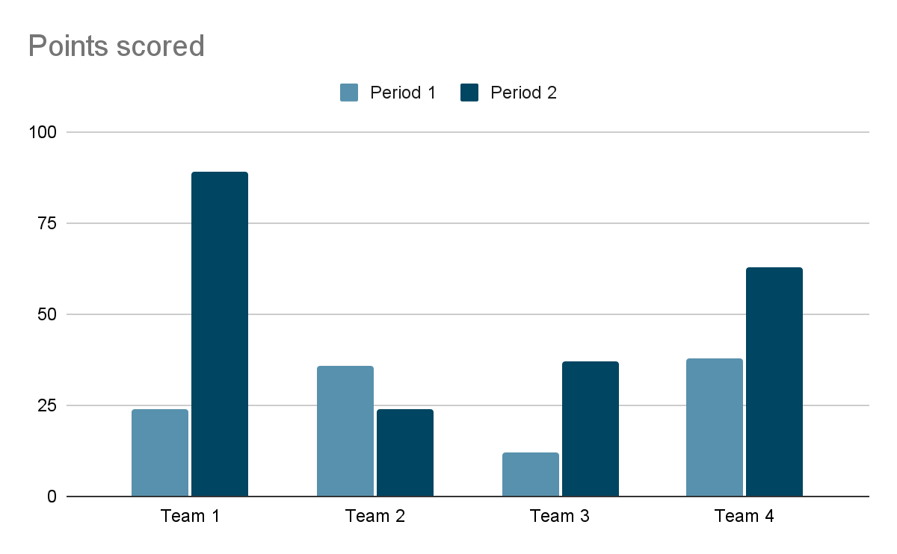

# **Produktuak**

| **Product Name** | **Product_Id** | **Price** |
| --- | --- | --- |
| Tyres | 5026 | 63.25€ |
| Oil | 2038 | 10.15€ |
| Diesel 10L | 100 | 18.5€ |
| Petrol 10L | 101 | 19.26€ |

# **Langileak**

Enpresaren langileen datuak agertuko dira txosten honetan.

| Id | Name | Surname | tlf | rank |
| --- | --- | --- | --- | --- |
| 42329 | Patrick | Wuazoski | 567984316 | Director |
| 98324 | Harry | Calum | 875632643 | Employee |
| 12394 | Jack | Connor | 263475865 | Employee |

# **Bezeroak**

Enpresaren bezero guztiak agertuko dira txostenean.

| Name | Surname | tlf | email |
| --- | --- | --- | --- |
| James | Charlie | 984353756 | JamesChar@gmail.com |
| Oscar | Ryhs | 476345217 | Oscar22@gmail.com |
| William | Damian | 156098251 | WDamian@gmail.com |
| Jessica | Lauren | 765432876 | JessLa@gmail.com |

# **Urteko bezerorik onena**

| BEST USER!! |
| --- |
| 44444444A Felipe Gonzalez [fe.gonz@gmail.com](mailto:fe.gonz@gmail.com) |

| Urteko Gastua | 1235,21€ |
| --- | --- |
| Hilabeteko Gastua | 200,89€ |
| Batez besteko eguneko gastuak | 33.23€ |

# **Erreserbak**

Egun horretako erreserbak agertuko dira

| 25/03/2022 | Cabin1 | Cabin2 | Cabin3 |
| --- | --- | --- | --- |
| 8:00-9:00 | UserID |  |  |
| 9:00-10:00 |  | UserID |  |
| 10:00-11:00 |  |  | UserID |
| 11:00-12:00 | UserID |  |  |
| 12:00-13:00 |  |  | UserID |
| 13:00-16:00 | closed | closed | closed |